LAB EXPERIMENT RECORD

Set 15: Product Sales Analysis

Department | AIML
Course Code / Course Name | DSA0602 / Data Handling and Visualization
Experiment | Data Visualization using Tableau
Name | S.Naveen Kumar
Register Number | 192425176
Date | 8 October 2026
Day | Thursday

Aim
To analyse monthly product sales using a grouped bar chart, a stacked area chart and a table, and to build an interactive Tableau dashboard for exploring sales data.

Dataset: Monthly Product Sales

Product ID | Product Name | January Sales | February Sales | March Sales
1 | Product A | 2000 | 2200 | 2400
2 | Product B | 1500 | 1800 | 1600
3 | Product C | 1200 | 1400 | 1100

PROGRAM 1: Grouped Bar Chart of First Quarter Sales
Create a grouped bar chart to visualize the sales of each product for the first quarter. Label the chart elements.

Steps in Tableau:
- Connect to the sales file. Select January, February and March Sales, right-click and choose Pivot to get the fields Pivot Field Names (rename to Month) and Pivot Field Values (rename to Sales).
- Create a new sheet named "Grouped Bar".
- Drag Product Name to Columns, then drag Month to Columns next to it so the bars are grouped by product.
- Drag Sales to Rows (SUM) and Month to Color.
- Show Sales values as labels, set the title "Product Sales - First Quarter", and label the axes "Product" and "Sales".

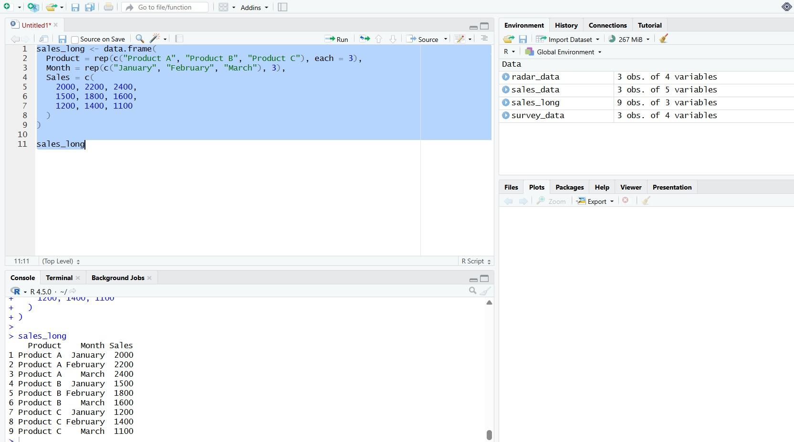
Output 1: Grouped Bar Chart of Product Sales (Q1)
Observation: Product A has the highest sales in every month and grows steadily (2000, 2200, 2400). Products B and C both peak in February and fall in March.

PROGRAM 2: Stacked Area Chart of Sales Trend
Generate a stacked area chart to represent the overall sales trend for all products over the three months.

Steps in Tableau:
- Add a Month Number field (January = 1, February = 2, March = 3) using a calculated field so that the month axis is continuous.
- Create a new sheet named "Stacked Area".
- Drag Month Number to Columns and set it to Continuous; drag Sales to Rows (SUM).
- Drag Product Name to Color and change the mark type to Area; Tableau stacks the areas automatically.
- Edit the axis labels to show month names, add the title "Sales Trend by Product" and show the legend.

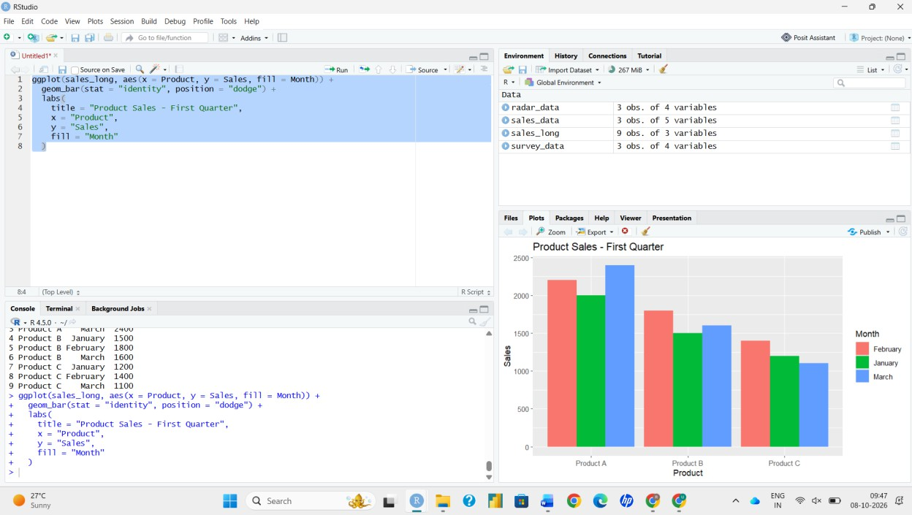
Output 2: Stacked Area Chart of Overall Sales Trend
Observation: Total sales rise from 4700 in January to 5400 in February and then dip to 5100 in March. Product A contributes the largest share of the total (about 43% of the quarter's 15200).

PROGRAM 3: Table of Monthly Sales Data
Build a table to show the monthly sales data for each product. Label the table elements.

Steps in Tableau:
- Create a new sheet named "Sales Table".
- Drag Product Name to Rows and Month to Columns.
- Drag Sales to Text.
- Use Analytics > Totals (or Worksheet > Show Totals) to add row and column grand totals.
- Add the title "Monthly Sales by Product" and format the values with thousand separators.

Expected totals (for verification):

Product | January | February | March | Total
Product A | 2000 | 2200 | 2400 | 6600
Product B | 1500 | 1800 | 1600 | 4900
Product C | 1200 | 1400 | 1100 | 3700
Total | 4700 | 5400 | 5100 | 15200

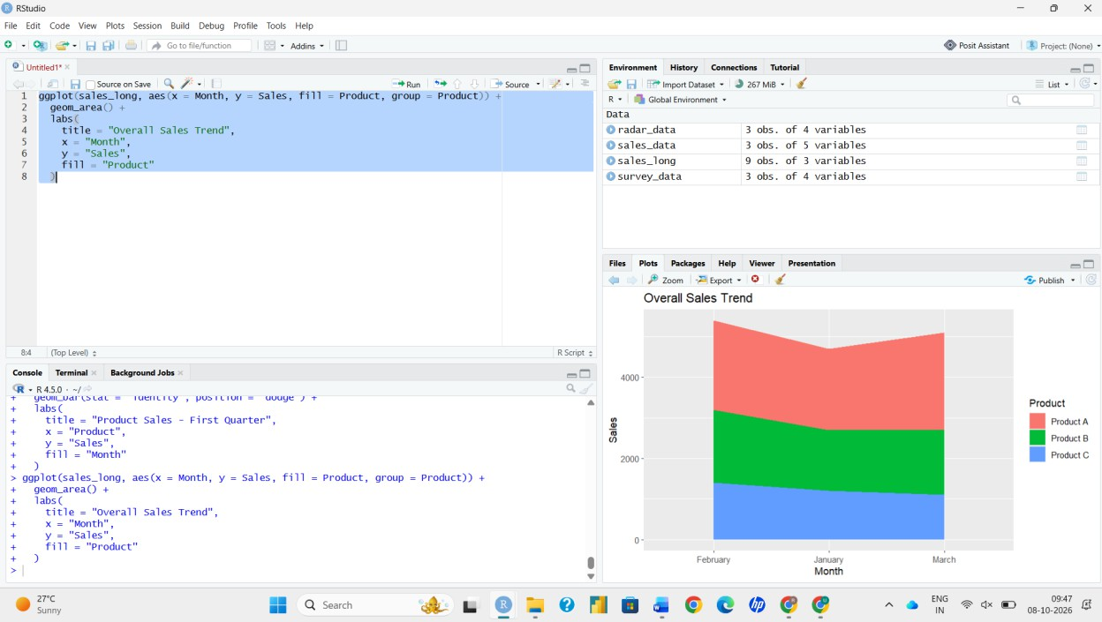
Output 3: Table of Monthly Product Sales
Observation: The table gives exact monthly figures; Product A is the top seller with 6600 units of sales in the quarter, followed by Product B (4900) and Product C (3700).

PROGRAM 4: Interactive Tableau Dashboard
Develop a Tableau dashboard combining the grouped bar chart, stacked area chart and table for interactive exploration of sales data.

Steps in Tableau:
- Click New Dashboard at the bottom of the workbook and rename it.
- Set Size to Automatic (or Fixed: Desktop Browser) from the Dashboard pane.
- Drag Grouped Bar, Stacked Area and Sales Table from the Sheets list onto the dashboard canvas.
- Add a Title (Dashboard > Show Title) and arrange the sheets using Tiled layout containers.
- Select the first chart and click Use as Filter so that selecting a product in the bar chart filters the area chart and the table.
- Use Dashboard > Actions to add a Highlight action, and enable Show Filters on the sheets for dropdown filtering.
- Click different marks to test interactivity and confirm all views update together.

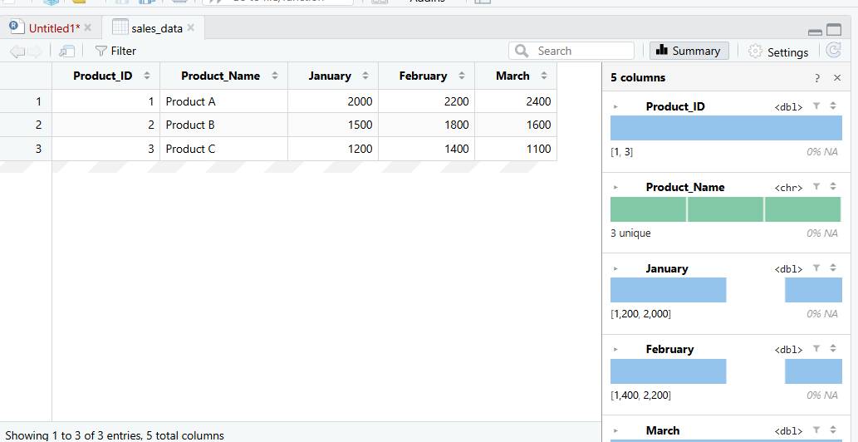
Output 4: Interactive Product Sales Dashboard
Observation: Selecting a product highlights its bars, its area in the trend chart and its row in the table, so product performance can be compared across months quickly.

Procedure
- Connect the product sales data to Tableau and pivot the three monthly columns into Month and Sales.
- Build the grouped bar chart with Product Name and Month on Columns and SUM(Sales) on Rows.
- Build the stacked area chart with Month Number on Columns, SUM(Sales) on Rows and Product Name on Color.
- Build the table with Product Name on Rows, Month on Columns and Sales as text.
- Combine the three sheets in a dashboard and add filter and highlight actions.
- Interact with the dashboard to explore sales by product and month.

Result
The monthly product sales data was successfully visualized using a grouped bar chart, stacked area chart and table, and an interactive Tableau dashboard was created for exploring sales data.

